OFFICE
For Sublease
Office Space

Regency Center
777 NW 63rd Street
Oklahoma City, OK 73116
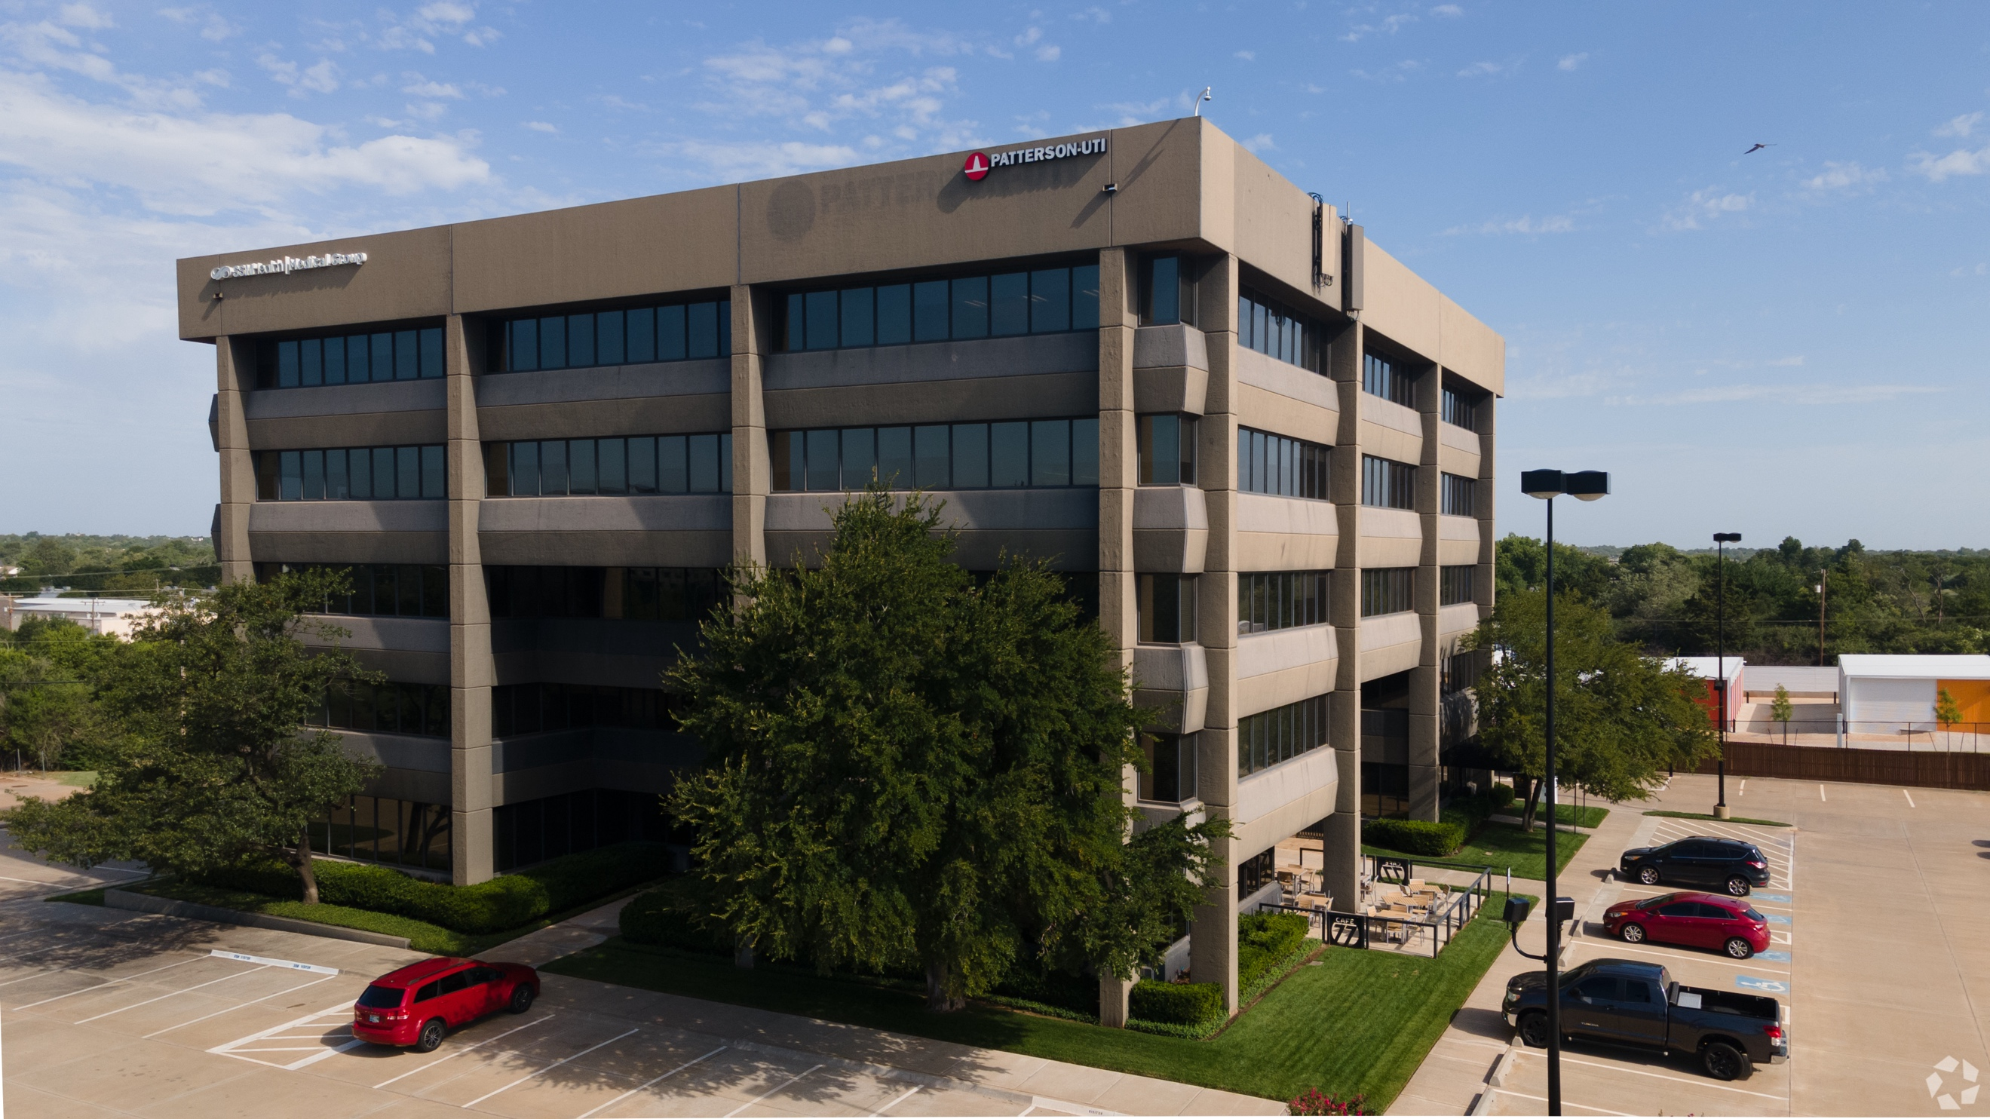

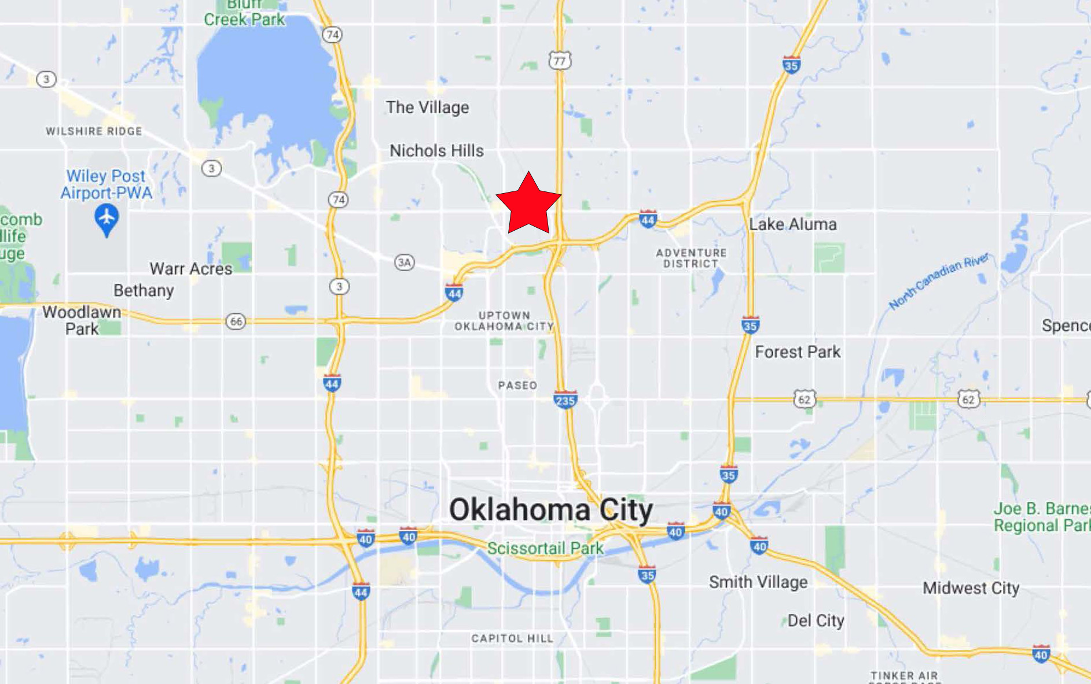

- 23,355 rsf
- Sublease Rate: Negotiable
- Sublease Term: October 31, 2024
- Available within 30 days
- Portion of 1st floor and entire 2nd floor
- Covered Parking Available
- FF&E: Negotiable
- Easy access to I-44 and Broadway Ext

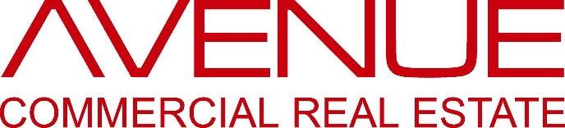
P. SCOTT WIECZOREK

5030 N. May Avenue, #435, Oklahoma City, OK 73112 405.698.1150 (oﬃce) • 405.210.3894 (mobile)

scott@avenuecre.com • www.avenuecre.com

OFFICE For Sublease

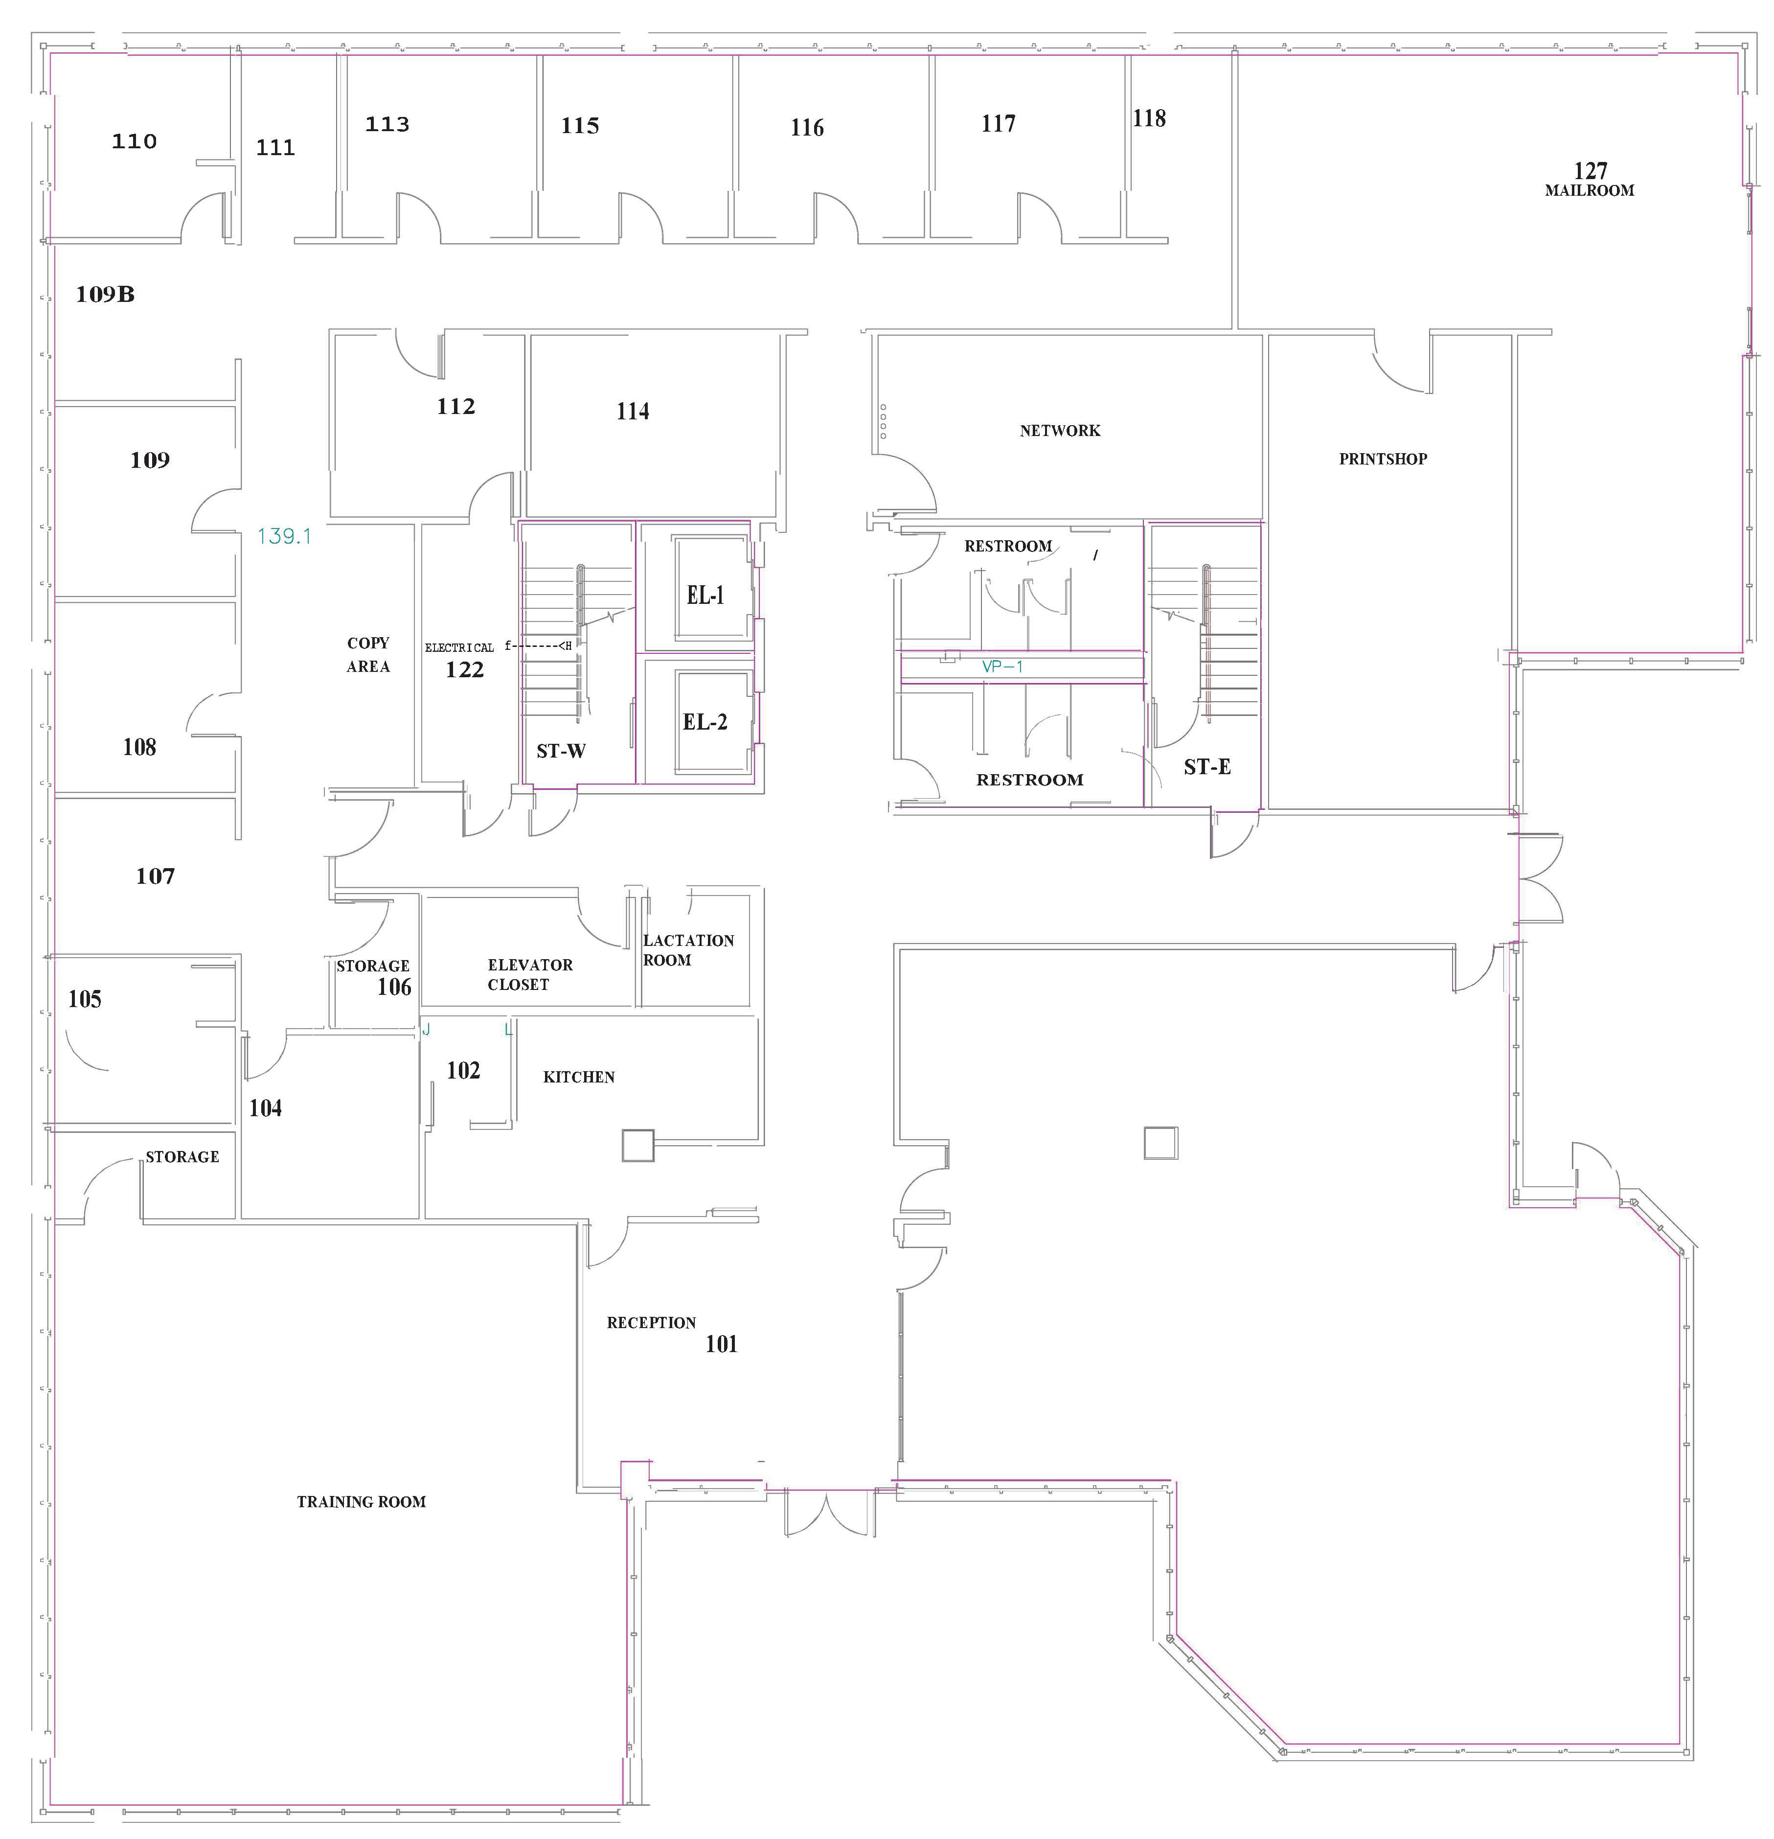

First Floor
+/- 8,990 SF

OFFICE For Sublease

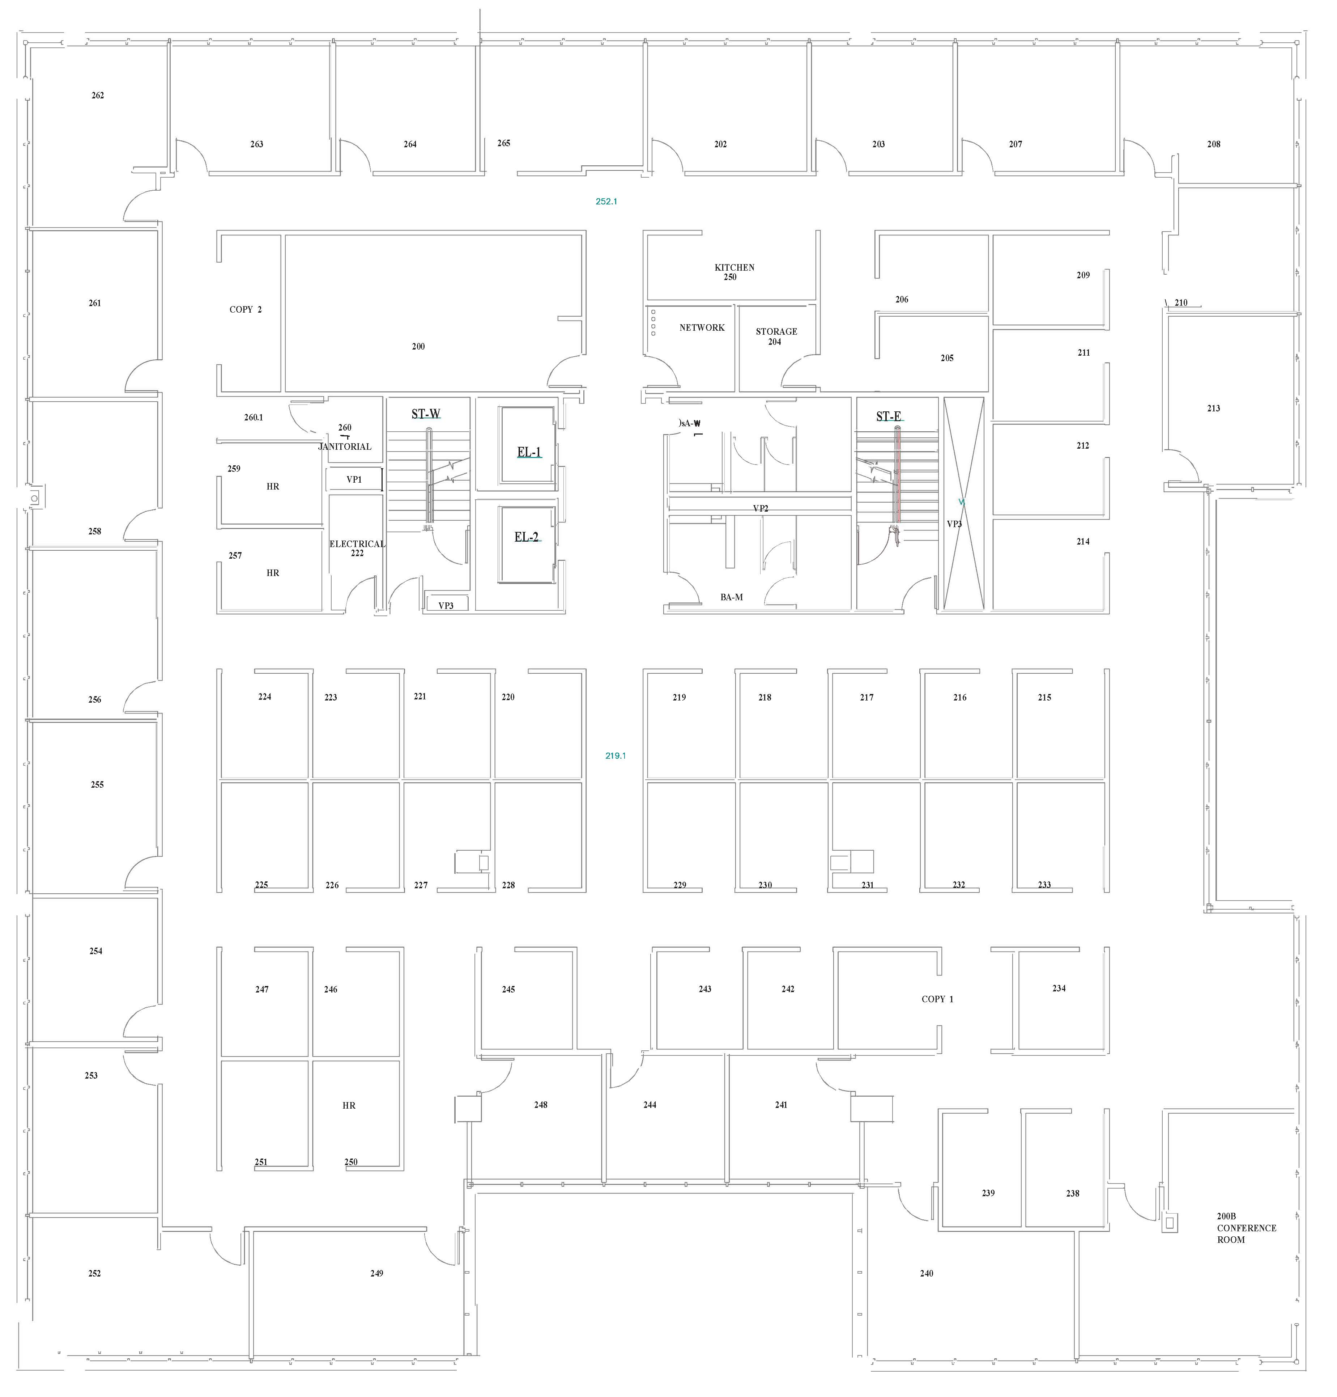

Second Floor
+/- 15,365 SF

